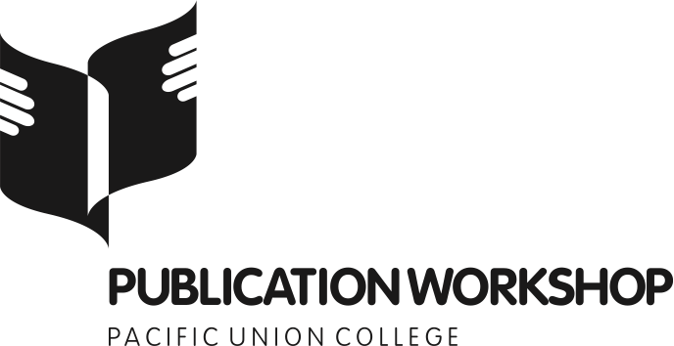

Presentation Handout
Interviews
Peter Katz, Ph.D.
Wednesday, 5 Sept – 2:00pm
pjkatz@puc.edu

Purpose for an interview:

- Information
  - Lend credibility
  - Hunting for sound-bites
- Human interest
  - Tell a story
  - PS. This one is better

- Everything is a story. Your goal is to help someone tell theirs.
- What is their role in the story (character)?
  - What is your role in the story (interview persona)?
- What is the plot (trajectory) of your interview?

Strategies:

- Play a role
- Build rapport
- Have a conversation
  - Record
  - Don’t think about data-mining
- Question trees
  - Key points
- Follow-up questions: get them to talk
  - How and Why questions
  - Emotion questions
- If they aren’t talking, put the words in their mouth—even if they spit them back
  - “Would you say xyz?”
- Be willing to change the angle of your interview if it isn’t working
- Be willing to scrap the interview if it flops

